### 

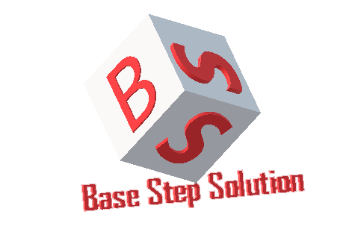

Change Management Plan

Văn Lang Admissions

# Revision Table

|  |  |  |  |
| --- | --- | --- | --- |
| Author | Date | Reason for changes | Version |
| Minh Đoàn | 14/10/2016 | Initial Document | 1.0 |
| Xuân Thái Hiền, Minh Đoàn | 14/10/2016 | Update data | 1.1 |
| Minh Đoàn | 23/10/2016 | Update data and template | 1.2 |
| Minh Đoàn | 8/11/2016 | Add legendary board of process | 1.3 |
| Minh Đoàn | 8/1/2017 | Fix process | 1.4 |
| Minh Đoàn | 9/2/2017 | Fix template | 2.0 |
| Khoi Nguyen | 24/5/2017 | Fix Logo | 2.1 |

Table of Contents

Revision Table 1

1. INTRODUCTION 3

1.1. Purpose 3

1.2. Audience 3

1.3. Reference 3

2. Process 4

2.1. Process Flow 4

2.2. ACtivities 5

3. Evaluating and Authorizing change request 6

3.1. Priority of change request 6

3.2. Change request type 6

4. Roles and Responsibilities 7

# INTRODUCTION

## Purpose

This document is description about Change Management Plan. It introduces change management process and tools used to manage change in project.

## Audience

The main audiences of this document are: Mentor, Base Steps Solution Team and may be customer of they need.

## Reference

BSS_ChangeRequestForm_V1.0

# Process

## Process Flow



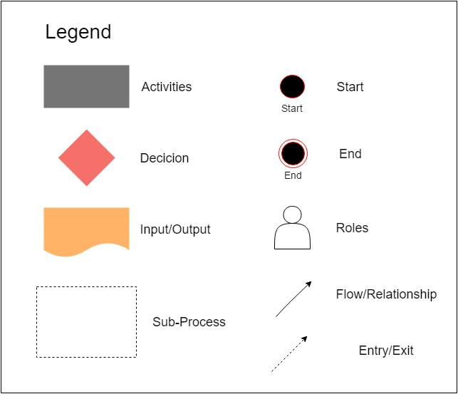

## ACtivities

|  |  |  |  |  |
| --- | --- | --- | --- | --- |
| Action | Description | Input | Output | Role |
| Change Request | Given the changing project requirements | List change | Change request form | Stakeholder |
| Analyze Impact | Analyze this change impact how the system | Change request form | List of change impact | Change Control Board |
| Assign Resource | If accepted, it will be assigned to the development team to update the changes. | Change request form of list agree changes | Assigned task | Change Control Board |
| Execute | Execute change assigned | Assigned task | Implemented change request | Development Team |
| Test | Check to see if the change has the right as described originally or not? | Implemented change request | Test change report | Development Team |
| Reject | If it won’t be accepted, it will be reject to the development team to delete the changes. | Change request form | Log change | Change Control Board |
| Close | Complete and close the change. |  | Change report | Development Team |

# Evaluating and Authorizing change request

## Priority of change request

|  |  |
| --- | --- |
| Priority | Description |
| High | Changes impact to process, cost, duration, time. |
| Medium | Changes impact to deliverables, product. |
| Low | Changes impact to resources, scope and quality. |

## Change request type

|  |  |
| --- | --- |
| Type | Description |
| Scope | Change affecting scope |
| Time | Change affecting time |
| Duration | Change affecting duration |
| Cost | Change affecting cost |
| Resources | Change affecting resources |
| Deliverables | Change affecting deliverables |
| Product | Change affecting product |
| Processes | Change affecting process |
| Quality | Change affecting quality |

# Roles and Responsibilities

|  |  |  |
| --- | --- | --- |
| Role | Responsibilities | Assigned to |
| Stakeholder | Changes request | Customer, BSS-Team |
| Change Control Board | Analyze, evaluate impact of changes request and make decision to change or not. | Team Leader |
| Development Team | Implement changes. | BSS-Team |